**Technical Update – Feed Markets**

Information correct as at 09:00am on 28.07.2023

* Russian bombing of port infrastructure took markets by surprise.
* Some rain has fallen in soya/maize growing areas of US, but more needed.
* Catchy Northern European weather is hampering the harvest here.
* Crude oil increases significantly to around $83/barrel.

**Overview:**

The refusal of Russia to renew the Ukraine export deal on 15th July was largely expected and factored into agricultural commodity prices. However, the severe bombing of grain stores and infrastructure in Odessa and other ports along the Danube close to Romania was not. This has dramatically reduced the ability of Ukraine to export much of its agricultural crops, thus further reducing the global supply side. Another big concern is that if Ukraine retaliates and attacks Russian vessels in the Black Sea then prices could increase up to levels they reached at the start of the conflict.

Weather around the world continues to affect the outlook for crops. Wet conditions in northern and parts of eastern Europe are slowing harvest whilst dry weather in southern Europe and the US is reducing yields.

The US Federal Reserve increased interest rates by 0.25% on 26th July but did not indicate that further rate rises would definitely happen. The $ weakened against most currencies including the £, leaving it at $1.30.

Improving global economic news and the Black Sea situation has caused oil prices to increase to around $83/barrel for Brent Crude

**Cereals:**

The Russian attacks on the Black Sea ports available to the Ukraine in the last week have caused a surge in cereal prices. Last year around 33MT of grain was exported from the Ukraine via this route with a further 15MT via Romanian Black Sea ports, the next most effective outlet. Ship owners and insurers are already very concerned and if Ukraine attacks Russian ships carrying grain prices could see further significant increases.

The good Brazilian Zafrina maize crop is now being harvested but will not be enough to make up for any significant losses in the US crop and the likely lower exportable Ukraine crop. With global maize stocks:use ratio at only 26%, before any further downgrades to supply, prices are likely to rise.

In the US the recent rains have reduced the area of the mid-West in “drought” from 65% to 54% and NDVIs from satellite imagery have improved. Good/excellent ratings have also improved from around 50% in June to 57% now – see chart below – but although this is much better than in 2012 it is still the lowest score in the last 10 years and the outlook is for more dry weather over the next few weeks.

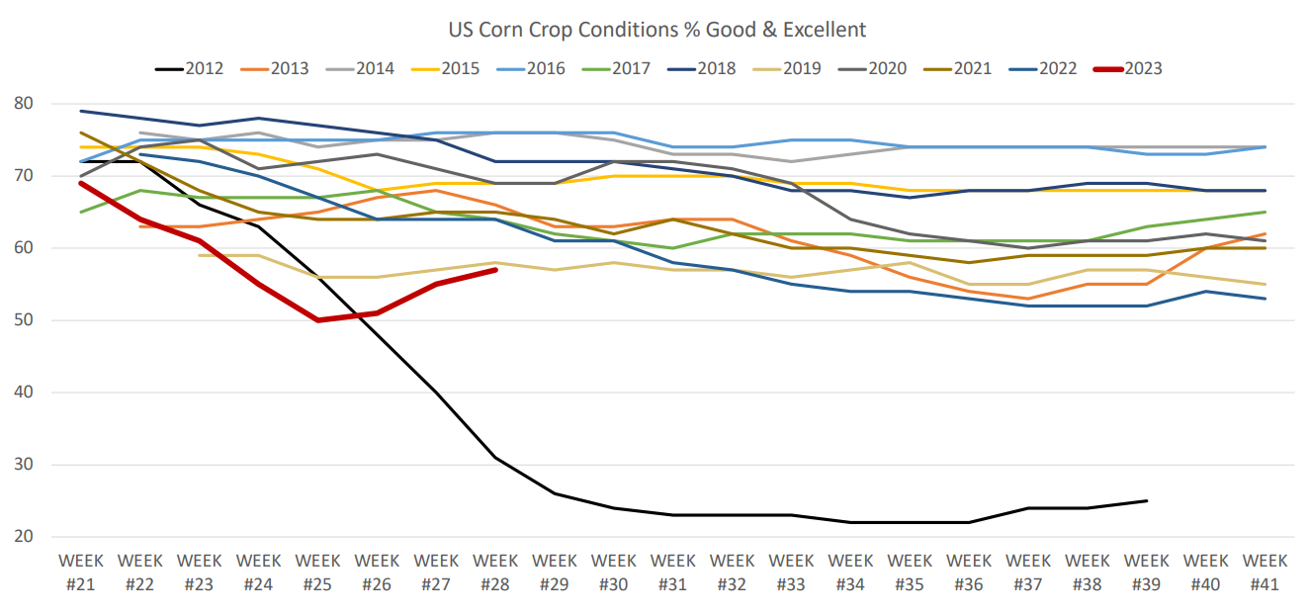

For wheat the US funds have been holding short positions for a long time but are finally starting to see the risks to production and have started selling, which has contributed to some of the recent price increases.

Wet weather in parts of Northern and Central Europe as well as Russia is hampering harvest with Russia only harvesting 14% of their crop compared to 22% at this time last year. In other key spring crop growing areas the dry weather is threatening final yields, although there is a way to go yet before harvest.

The forecast demand from the major importing nations for 2023/24 remains high, below left, but the stocks:use ratio of the major exporters was low at only 25% before the latest effects of geopolitics and weather.

The large 2023 UK wheat crop and the strong £ have combined to increase the UK feed wheat discount to Paris milling wheat to around 20 Euros/t. A similar size UK wheat crop is forecast for 2024.

The UK barley harvest is being slowed by the wet weather. Variable yields and qualities are being seen from the crop harvested so far and feed barley is still trading at around £25-30/t discount to wheat. This represents a continued opportunity for inclusion in dairy diets/compounds at current prices. The latest figures from DEFRA show an increase in poultry numbers on farms, indicating an increase in demand to come.

November UK forward wheat prices rose around £30/t from June levels to £216/t following the events in the Black Sea area but in recent days this has fallen back to £206/t. The previous advice for wheat was to have 100% cover through to harvest and up to 50-60% cover for next winter. The risks of further escalation of the war in the Black Sea is high and could push prices back to £250-300/t. Therefore, it will still be worth increasing cover further at current prices if needed.

The more risk averse may want to consider taking an even more defensive position and increasing cover to 100% through to Q1 2024

**Proteins:**

Brent crude oil has increased from $73/barrel to around $83/barrel in the last month due to improving global economic indicators, cuts made by OPEC+ (Saudi Arabia in particular) and events in the Black Sea. This has helped to push the price of vegetable oils higher across the board along with crush margins. The recent USDA reduction in the estimated US soyabean planted area from 87.5M Acres in March to 83.5M Acres in June has also helped to push prices higher.

The very dry conditions in many areas of the US caused the soya crop to get off to a poor start but rain during late June/early July has improved things. However, dry conditions have now returned and the good/excellent rating has fallen back to a relatively poor 54%. This is also adding to price pressure as the US funds have moved to longer positions.

Export demand for US soyabeans has been low as Brazilian material is cheaper – see below right.

With the strengthening El Nino weather pattern forecast to benefit the next Argentinian crop and Brazil also forecasting another record crop in 2024 the longer-term outlook is good. However, short-term stocks are tight following the poor 2023 Argentinian crop so a lot hinges on the US crop and the effect the weather will have on this over the next 3-4 months.

Oilseed rape/canola crops in the EU and Canada are generally looking good although dry weather in southern and eastern Europe has held back crops there. Despite the change to a drier El Nino in Australia their OSR crop is also looking good so far due to residual moisture from the wetter La Nina pattern over the last 3 years.

Sunflower and rape seed exports from Ukraine have been put in doubt by the recent events in the Black Sea.

Conditions in Indonesia and Malaysia have improved and their NDVI scores are well above average, suggesting a good palm crop to come.

UK soyameal prices have continued to rise to around £455/t for August to October before falling to £430/t for November to April 2024. Rapemeal remains in short supply in the north but has become available again out of Erith at around £267/t through to April 2024 – only around £10-15/t above previous low prices for winter. For southern ports the price is around £285/t for the same period

Soya hulls remain around £210-215/t for November to April and are still around £50/t cheaper than sugar beet pulp.

Demand for maize distillers in the US has increased and prices here have gone up slightly to around £277/t for November to April.

With all these products volatility remains as the weather and geopolitical events unfold so the advice is to continue to take forward cover as pricing opportunities arise.

For further discussion or to help with any questions that you may have, please contact Consultant Support on consultantsupport@kiteconsulting.com or 01902 851007 / 07542 403225